Exercise 2 – Implementing the Factory Method Pattern

Scenario
Develop a document management system that creates different document types such as Word, PDF, and Excel using the Factory Method Pattern.

Understanding the Factory Method Pattern
The Factory Method Pattern defines an interface for creating objects while allowing subclasses to decide which object to instantiate.

Project Name
FactoryMethodPatternExample

Implementation
interface Document{
void open();
}
class WordDocument implements Document{
public void open(){ System.out.println("Creating Word Document...");}
}
class PdfDocument implements Document{
public void open(){ System.out.println("Creating PDF Document...");}
}
class ExcelDocument implements Document{
public void open(){ System.out.println("Creating Excel Document...");}
}
abstract class DocumentFactory{
abstract Document createDocument();
}
class WordFactory extends DocumentFactory{
Document createDocument(){ return new WordDocument(); }
}
class PdfFactory extends DocumentFactory{
Document createDocument(){ return new PdfDocument(); }
}
class ExcelFactory extends DocumentFactory{
Document createDocument(){ return new ExcelDocument(); }
}
public class FactoryTest{
public static void main(String[] args){
new WordFactory().createDocument().open();
new PdfFactory().createDocument().open();
new ExcelFactory().createDocument().open();
System.out.println("\nDocuments created successfully using Factory Method.");
}
}

Sample Output
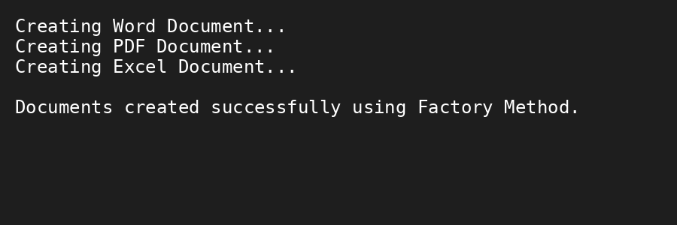

Conclusion
The Factory Method Pattern creates different document objects without exposing object creation logic, making the application flexible and extensible.

